**18 - Create a stored procedure**

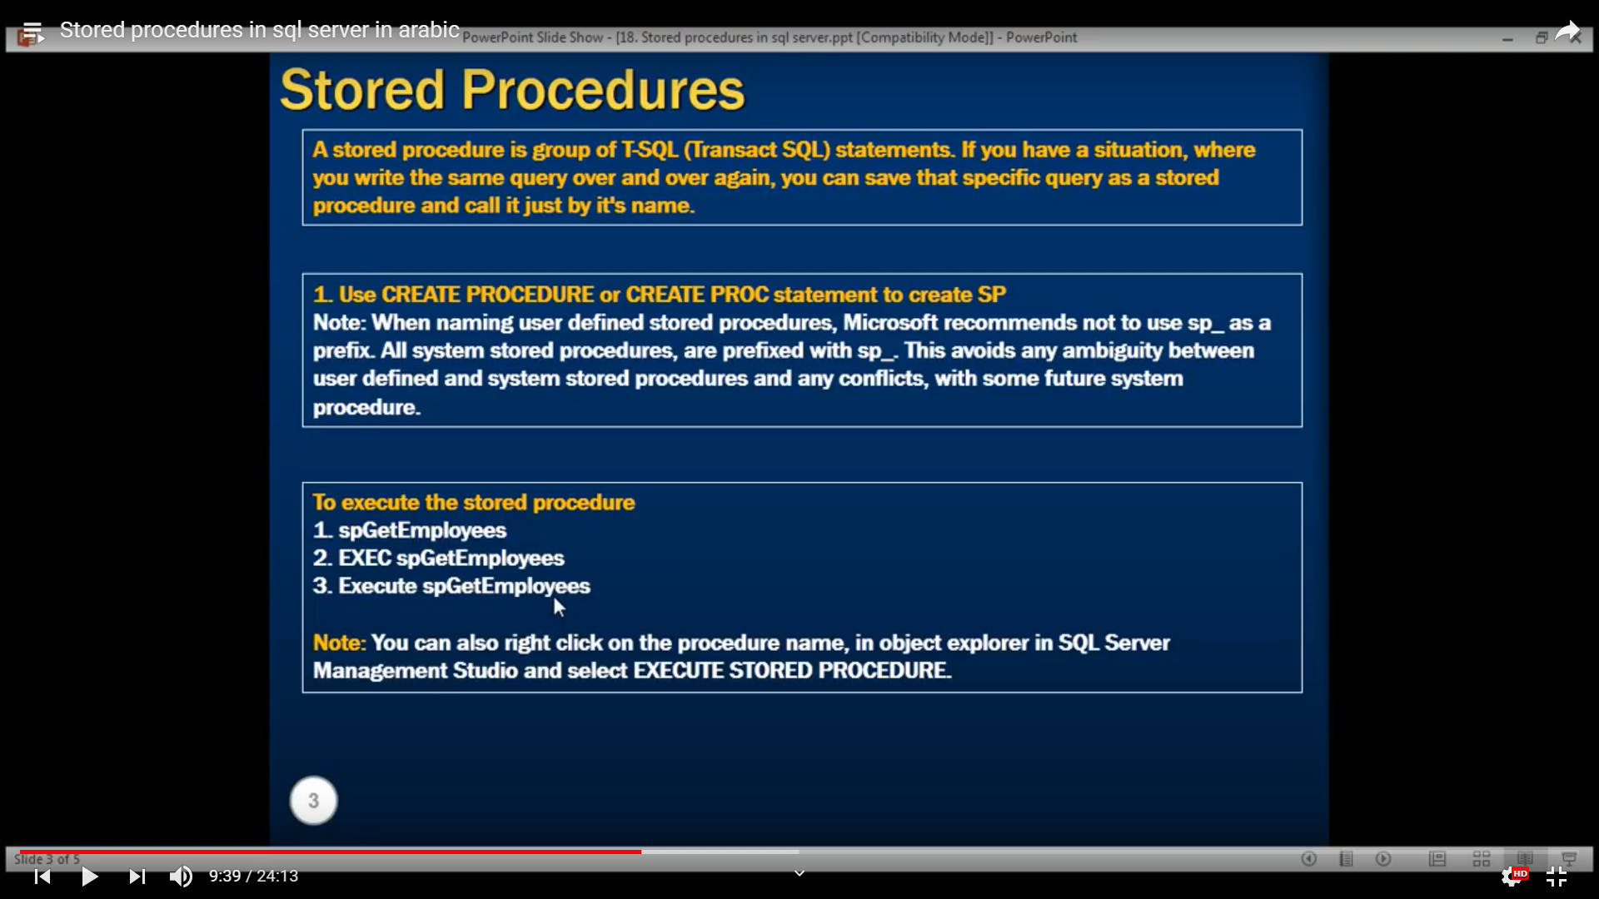

CREATE PROCEDURE spGetAuthors

AS

BEGIN

SELECT Name, Country FROM Authors

END

===

CREATE PROC spGetAuthors

AS

BEGIN

SELECT Name, Country FROM Authors

END

**Execute a stored procedure**

EXECUTE spGetAuthors Or EXEC spGetAuthors Or By de DBMMS

**Stored procedure with parameters**

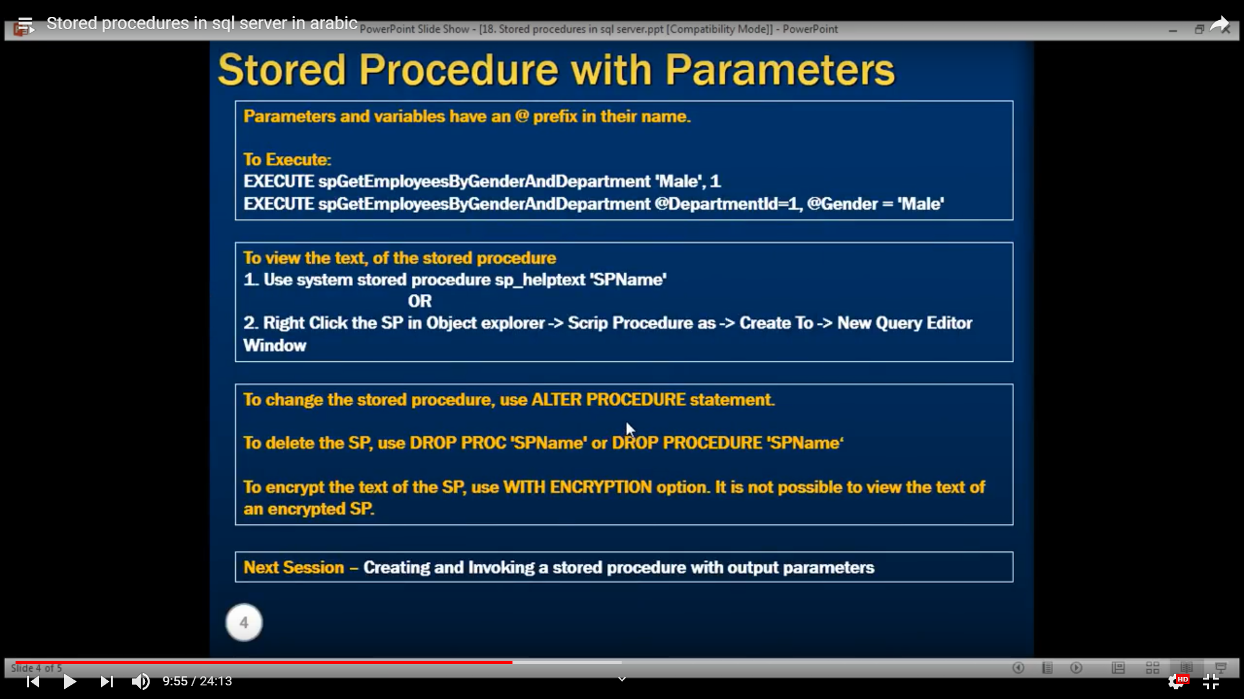

**Create stored procedure with parameters**

CREATE PROCEDURE spGetAuthorsByCountryAndName

@Country varchar(100),

@Name varchar(70)

AS

BEGIN

SELECT Name, Country FROM Authors

WHERE Name = @Name AND Country = @Country

END

**Execute stored procedure (we have to respect order)**

spGetAuthorsByCountryAndName 'USA','J.D. Salinger'

OR

spGetAuthorsByCountryAndName @Country = 'USA',@Name = 'J.D. Salinger'

OR Execute in DBMMS

**Get the script text of the stored procedure**

**sp_helptext** 'spGetAuthorsByCountryAndName'

Or by using DBMMS **🡪** Script Stored Procedure As 🡪 Create to 🡪 New Query

**Alter a stored procedure**

ALTER PROCEDURE spGetAuthors

AS

BEGIN

SELECT Name, Country FROM Authors ORDER BY Name

END

**Drop a stored procedure**

DROP PROC [dbo].[spGetAuthors]

**Create stored procedure with encryption**

CREATE PROCEDURE spGetAuthors

WITH ENCRYPTION

AS

BEGIN

SELECT Name, Country FROM Authors

END

sp_helptext 'spGetAuthors' , we will get :

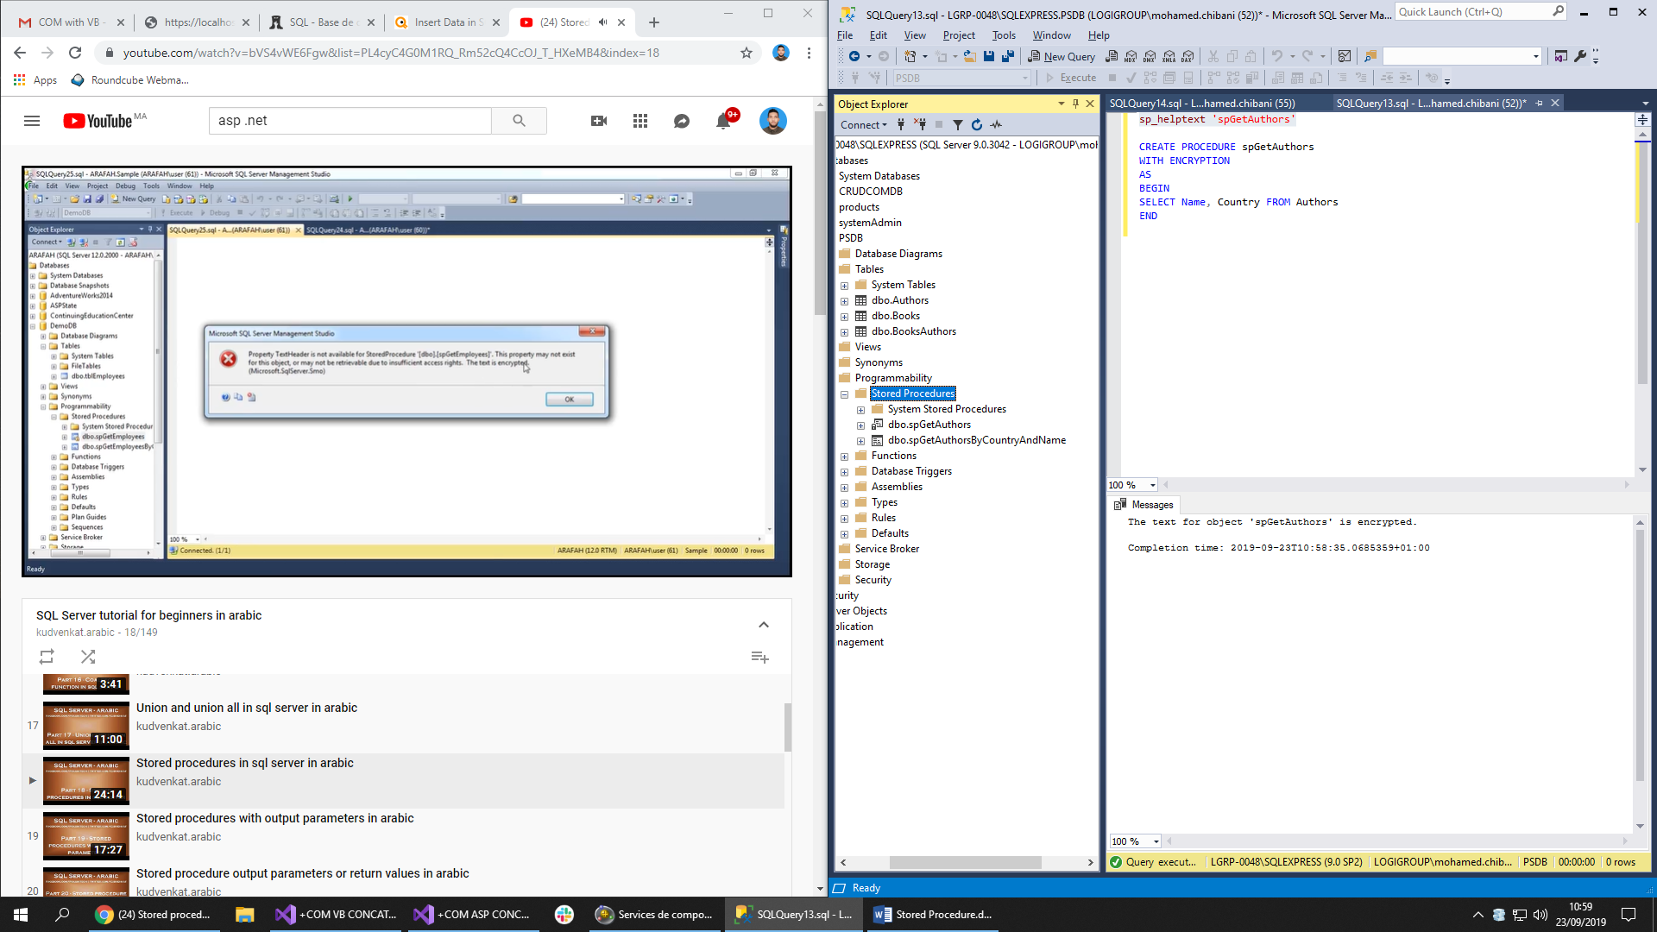

**19 - Stored** **procedure with output parameters**

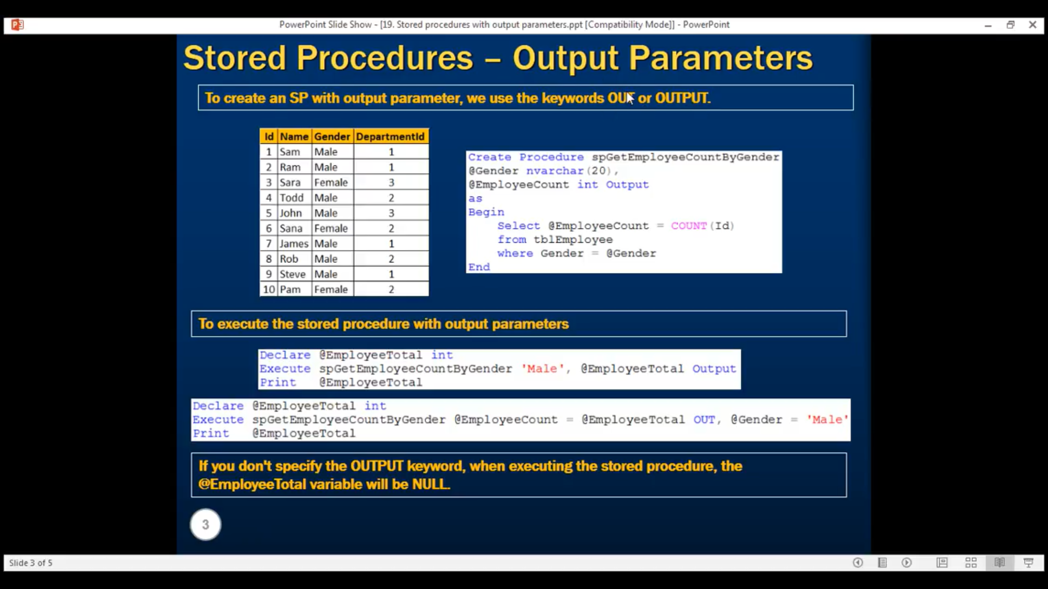

**Create the stored procedure with output or out**

CREATE PROC spGetAuthorsCountByCountry

@Country varchar(50),

@AuthorsCount int output

AS

BEGIN

SELECT @AuthorsCount = COUNT(*) FROM Authors

WHERE Country = @Country

END

**Execute the stored procedure with output**

DECLARE @TotalCount int

EXECUTE spGetAuthorsCountByCountry 'USA', @TotalCount out

PRINT @TotalCount

OR

DECLARE @TotalCount int

EXECUTE spGetAuthorsCountByCountry @Country = 'USA', @AuthorsCount = @TotalCount out

PRINT @TotalCount

**System stored procedures**

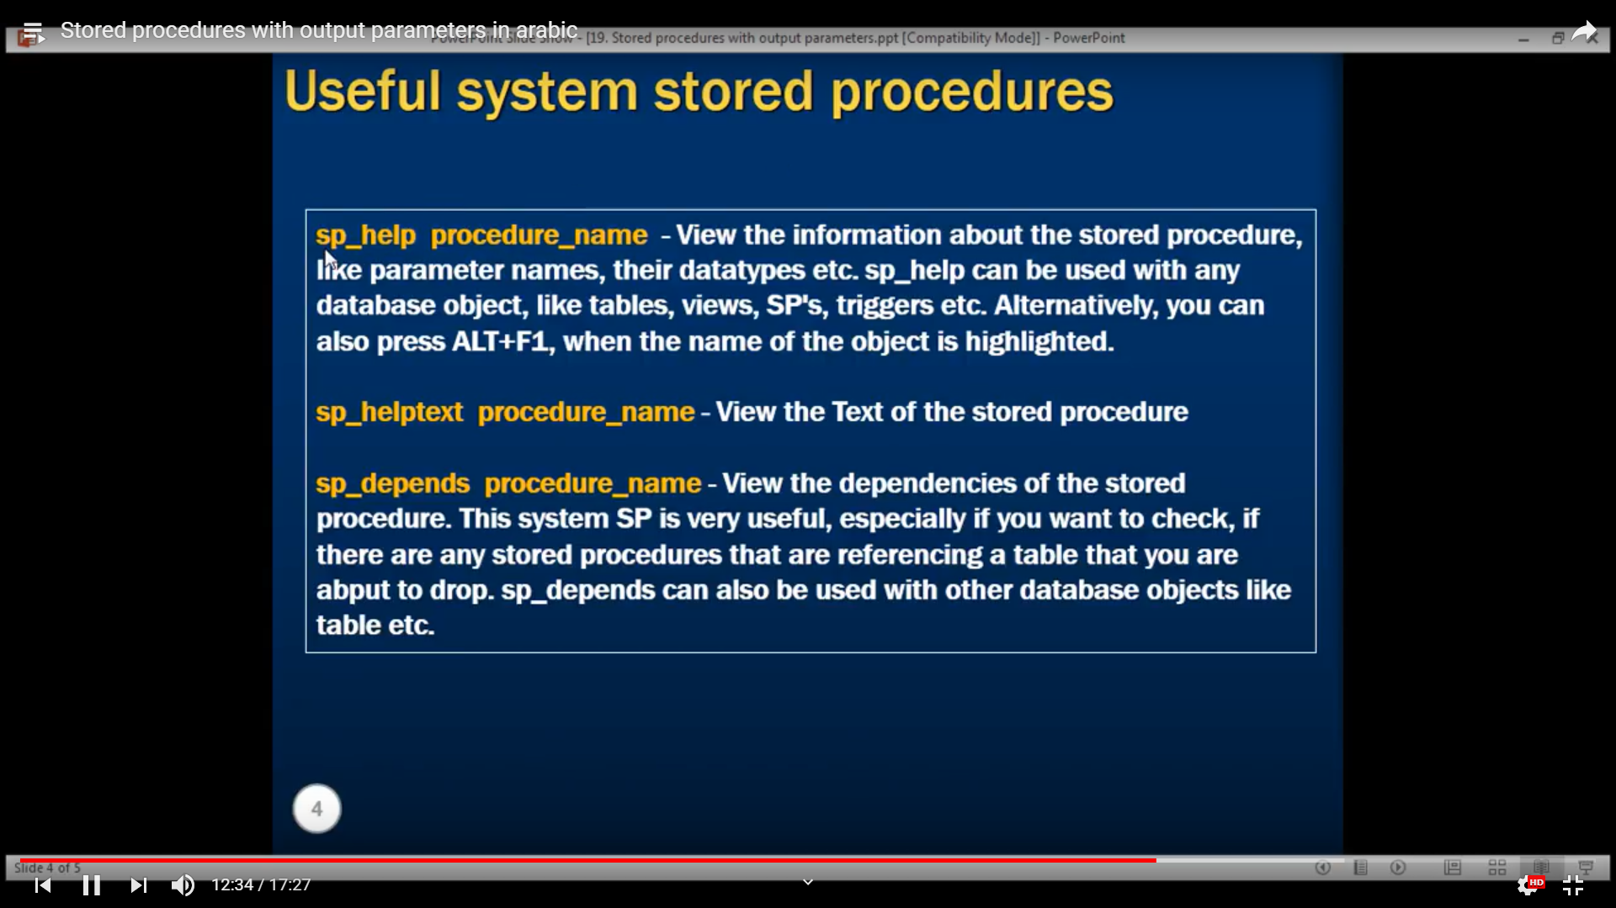

**Informations about the stored procedure**

sp_help spGetAuthorsCountByCountry

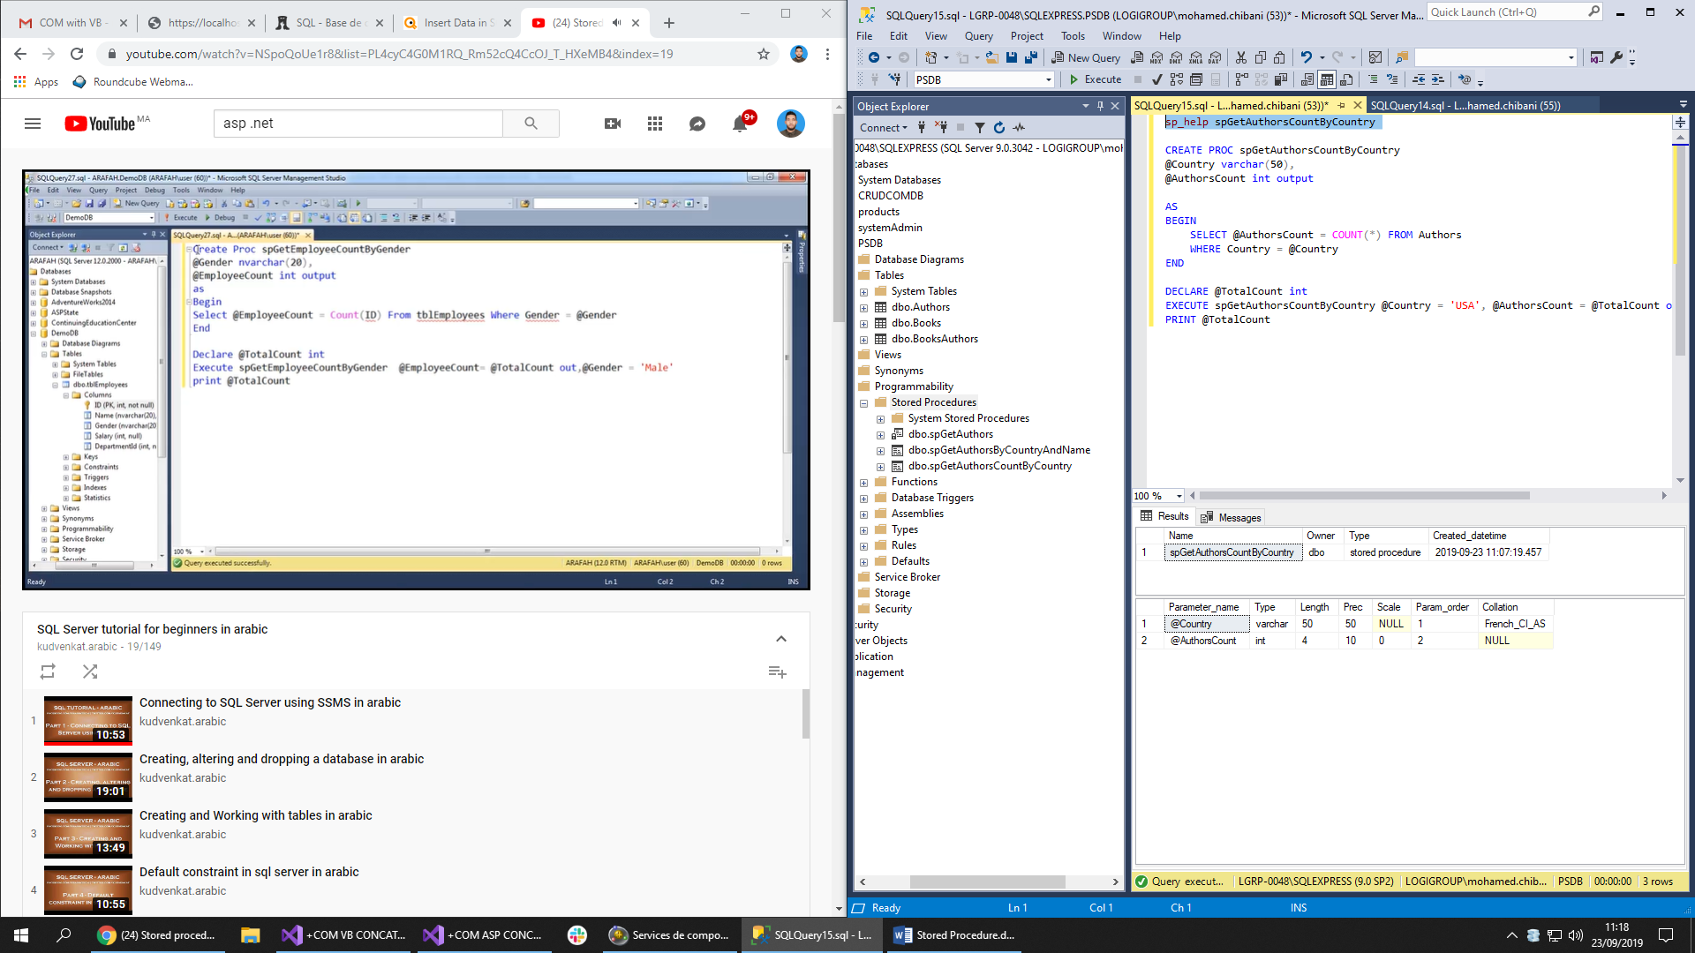

Or, we can get information with the navigation

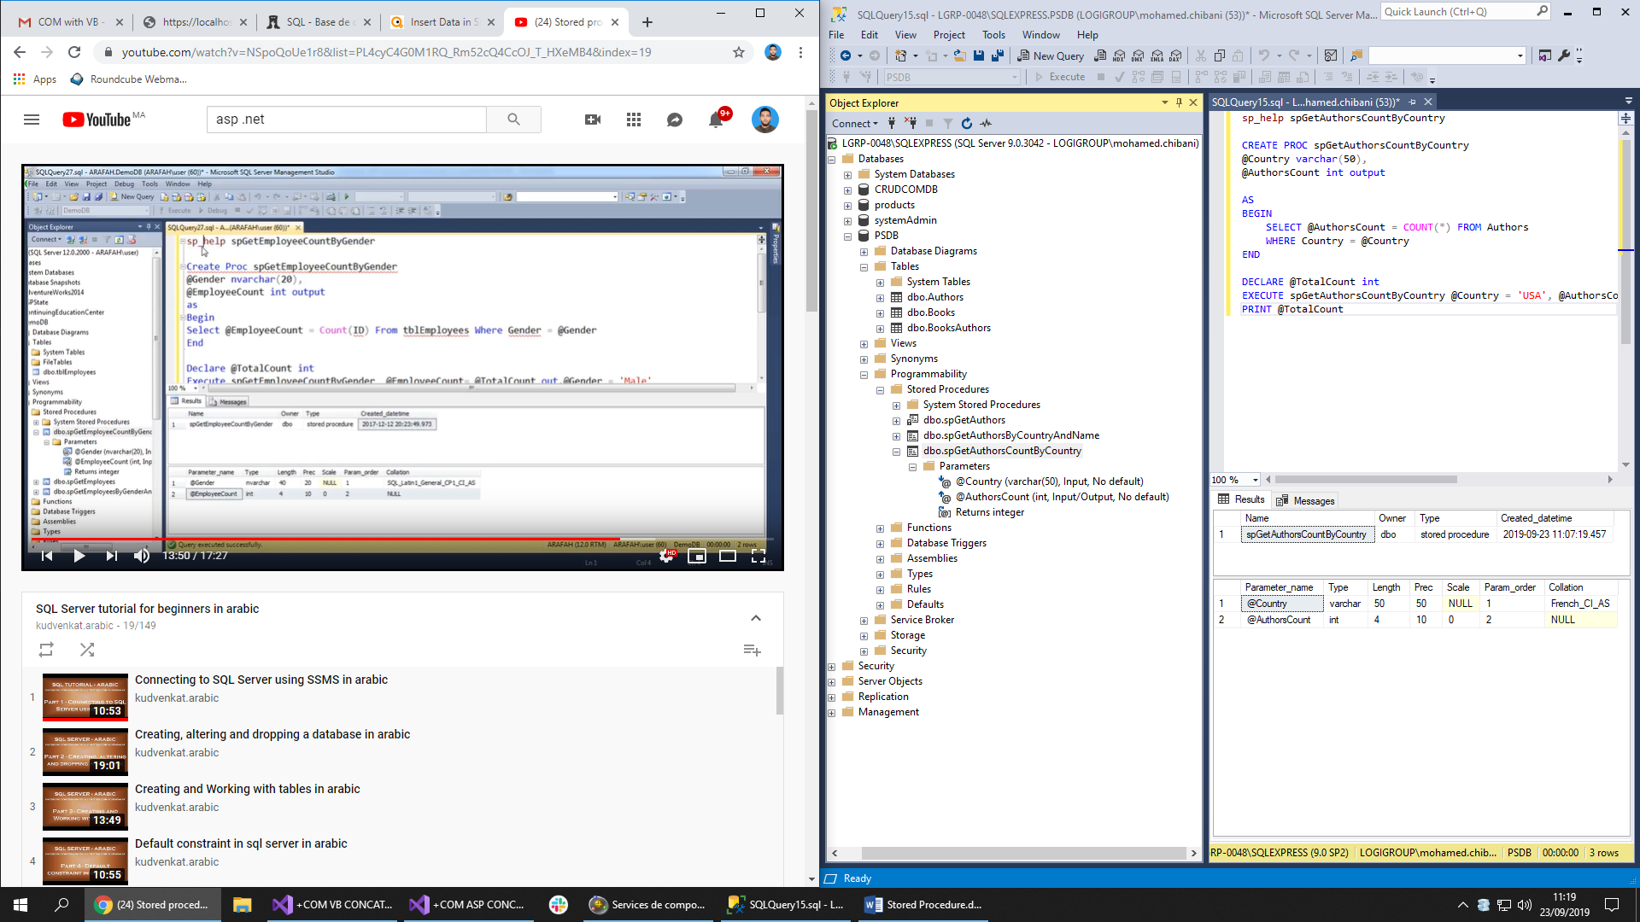

Sp_help work with any stored procedure object : table, view, triggers. AND we can select the stored procedure + ALT + F 1

Example : with table **Authors**

sp_help Authors

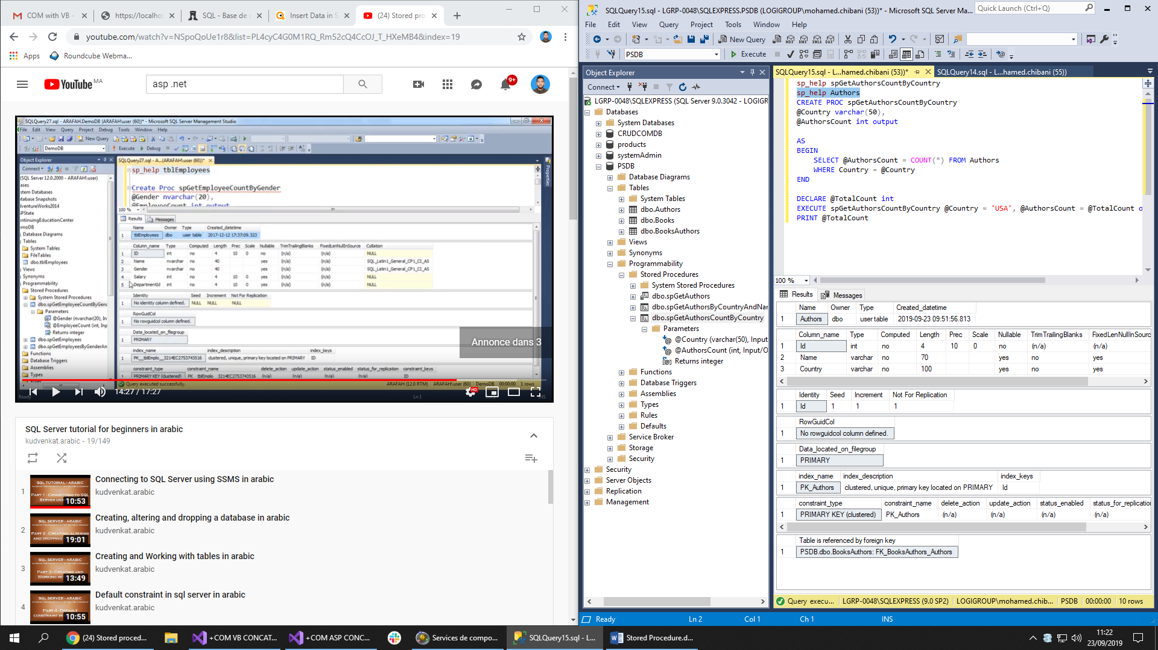

sp_depends spGetAuthorsCountByCountry

It returns the depends of the stored procedures or tables

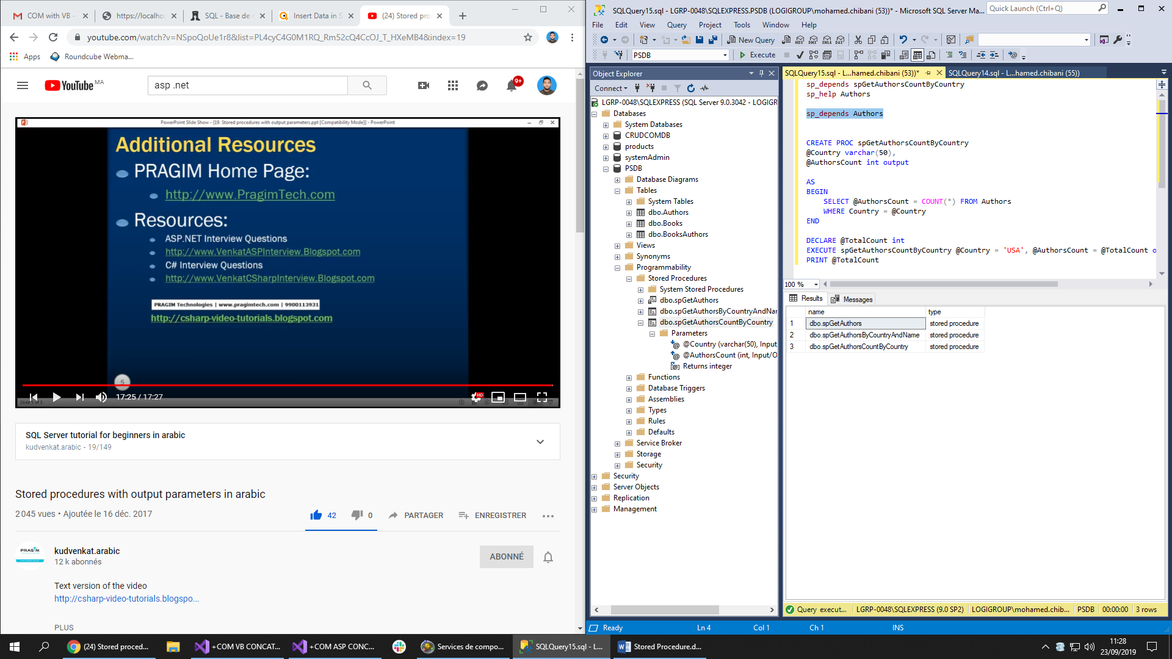

**20 - Stored procedure output parameters or return values**

If the execution of the procedure:

* Return 0: Execution successes
* Return 1: Execution failed

**Create a stored procedure with the return**

CREATE PROC spGetAuthorsCountByCountry2

AS

BEGIN

return (SELECT COUNT(*) FROM Authors)

END

**Execute the stored procedure**

DECLARE @TotalAuthors int

EXECUTE @TotalAuthors = spGetAuthorsCountByCountry2

PRINT @TotalAuthors

Example 2 :

CREATE PROC spGetNameByID1

@Id int,

@Name varchar(50) output

AS

BEGIN

SELECT Name FROM Authors WHERE Id = @Id

END

DECLARE @EmployeeName varchar(70)

EXECUTE spGetNameByID1 3, @EmployeeName out

PRINT @EmployeeName

The return must be an **int value,** if not , we will get an error of conversion

CREATE PROC spGetNameByID2

@Id int

AS

BEGIN

return (SELECT Name FROM Authors WHERE Id = @Id)

END

DECLARE @EmployeeName varchar(70)

EXECUTE @EmployeeName = spGetNameByID2 3

PRINT @EmployeeName

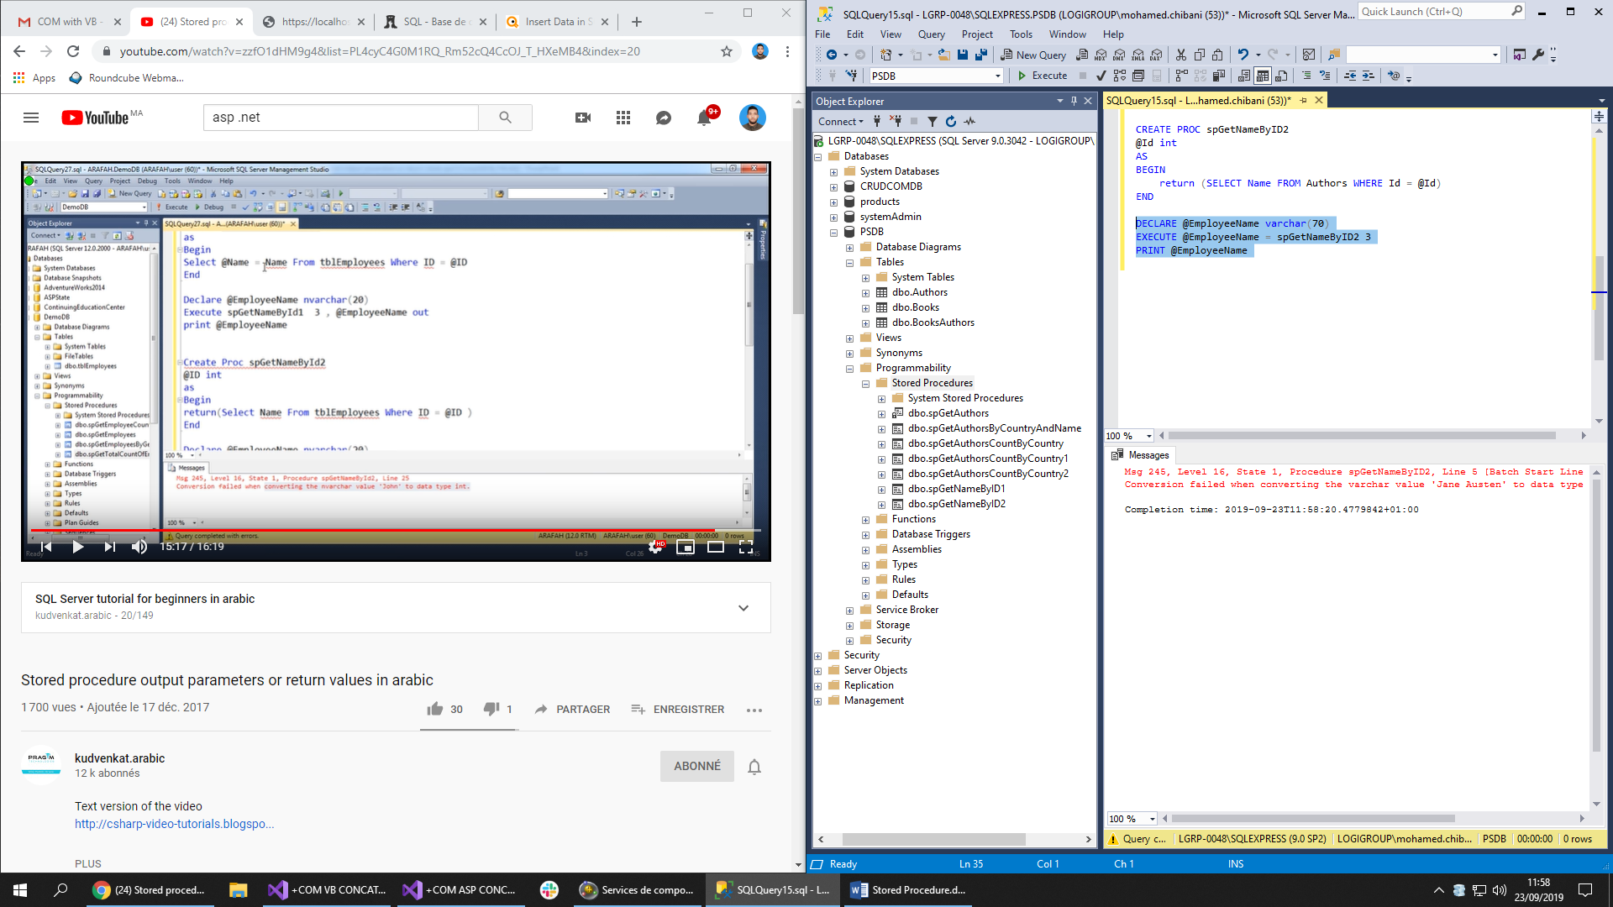

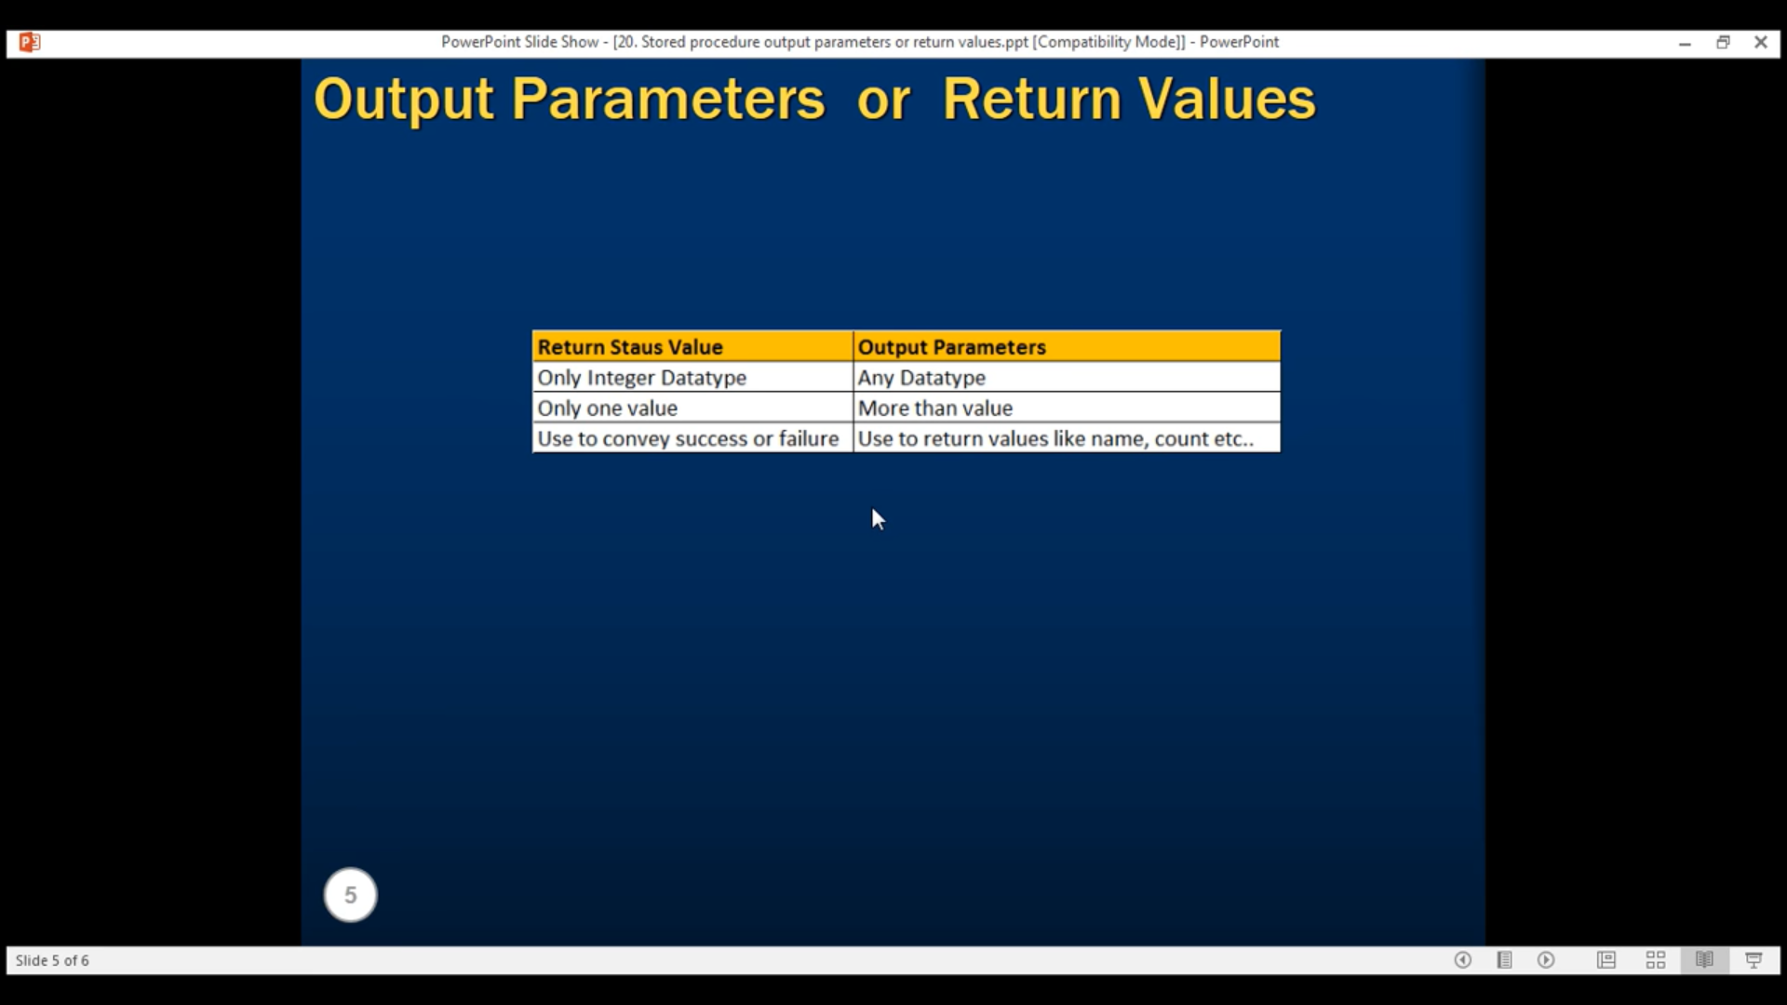

**21 - Advantages of using stored procedures**

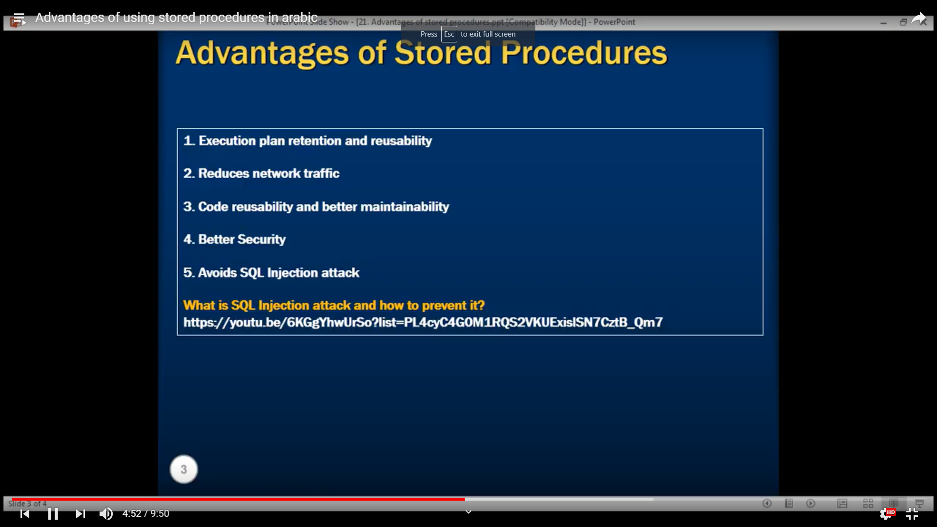

**1)**

3 phases: Checking – Compile - Generate the execute plan (which we will use it)

If we modify a simple query: it will regenerate the new execute plan

In the stored procedure, he uses the same execution plan () despite of modifications

**3) Maintainability at the same time for all applications**

------------------------------------------------------ 39 Views in sql server

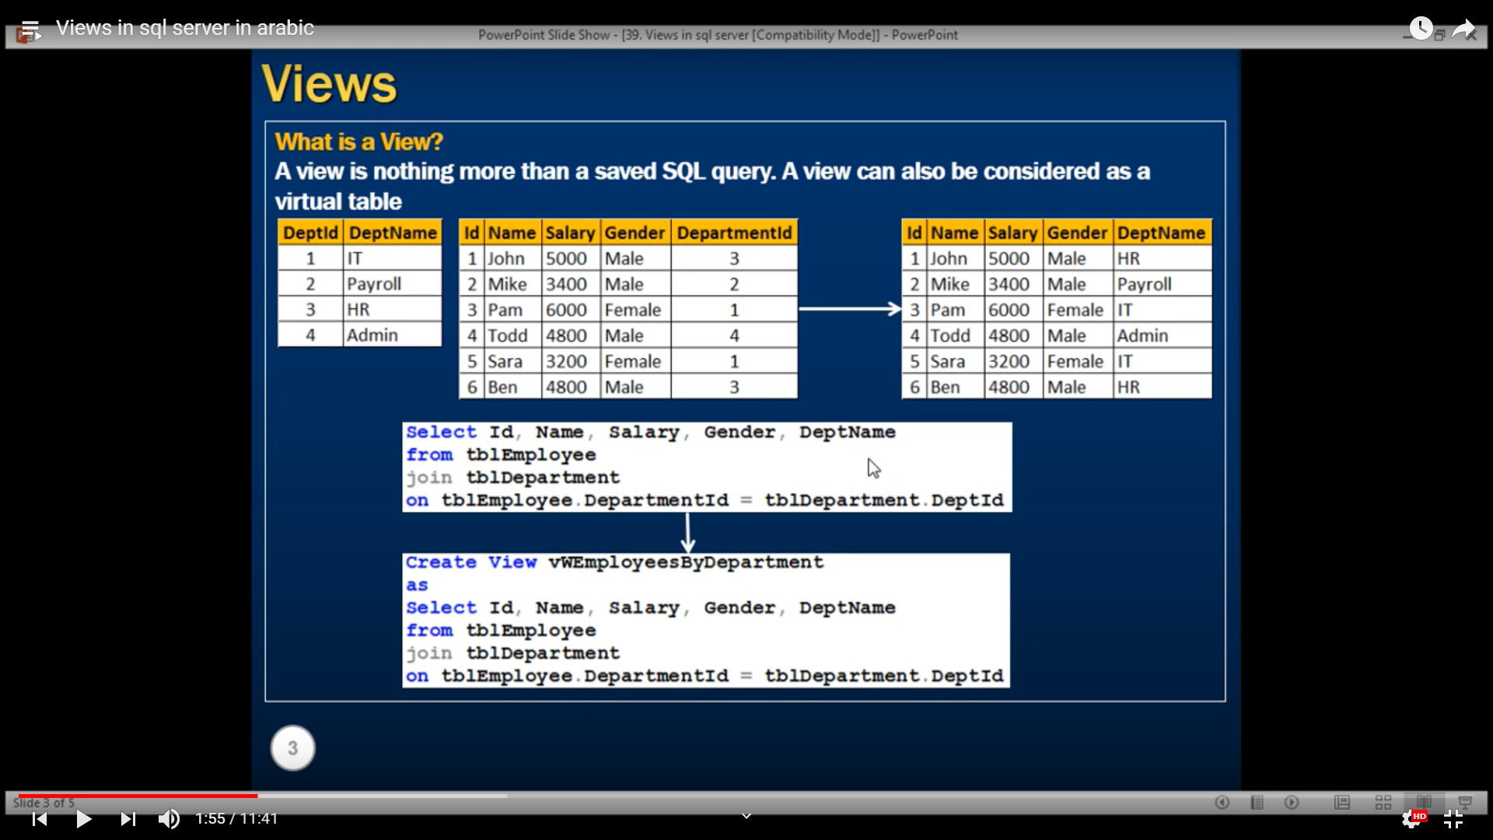

**Exemple:**

**Création et insertion des données**

create table tblEmployee

(

Id int Primary Key,

Name nvarchar(30),

Salary int,

Gender nvarchar(10),

DepartementId int

)

Create table tblDepartement

(

DeptId int Primary Key,

DeptName nvarchar(20)

)

Insert into tblDepartement values(1,'IT')

Insert into tblDepartement values(2,'Payroll')

Insert into tblDepartement values(3,'HR')

Insert into tblDepartement values(4,'Admin')

INSERT INTO tblEmployee values (1,'John', 5000, 'Male', 3)

INSERT INTO tblEmployee values (2,'Mike', 3400, 'Male', 2)

INSERT INTO tblEmployee values (3,'Pam', 6000, 'Frmale', 1)

INSERT INTO tblEmployee values (4,'Todd', 5000, 'Male', 4)

INSERT INTO tblEmployee values (5,'Sara', 3200, 'Female', 1)

**Création de la vue**

CREATE VIEW **vW**EmployeeByDepartement

as

SELECT Id,Name,Salary, Gender, DeptName

FROM tblEmployee

JOIN tblDepartement

ON tblEmployee.DepartementId = tblDepartement.DeptId

**Contenu de la vue**

SELECT * FROM vWEmployeeByDepartement

**Text de la vue**

sp_helptext vWEmployeeByDepartement

**Example 2 : utilisation de where**

Création de la vue :

CREATE VIEW vWITDepartement_Employees

AS

SELECT Id,Name,Salary, Gender, DeptName

FROM tblEmployee

JOIN tblDepartement

ON tblEmployee.DepartementId = tblDepartement.DeptId

WHERE tblDepartement.DeptName = 'IT'

Afficher le contenu

SELECT * FROM vWITDepartement_Employees

Ou bien on sélectionne la vue et on clique sur **Editer**

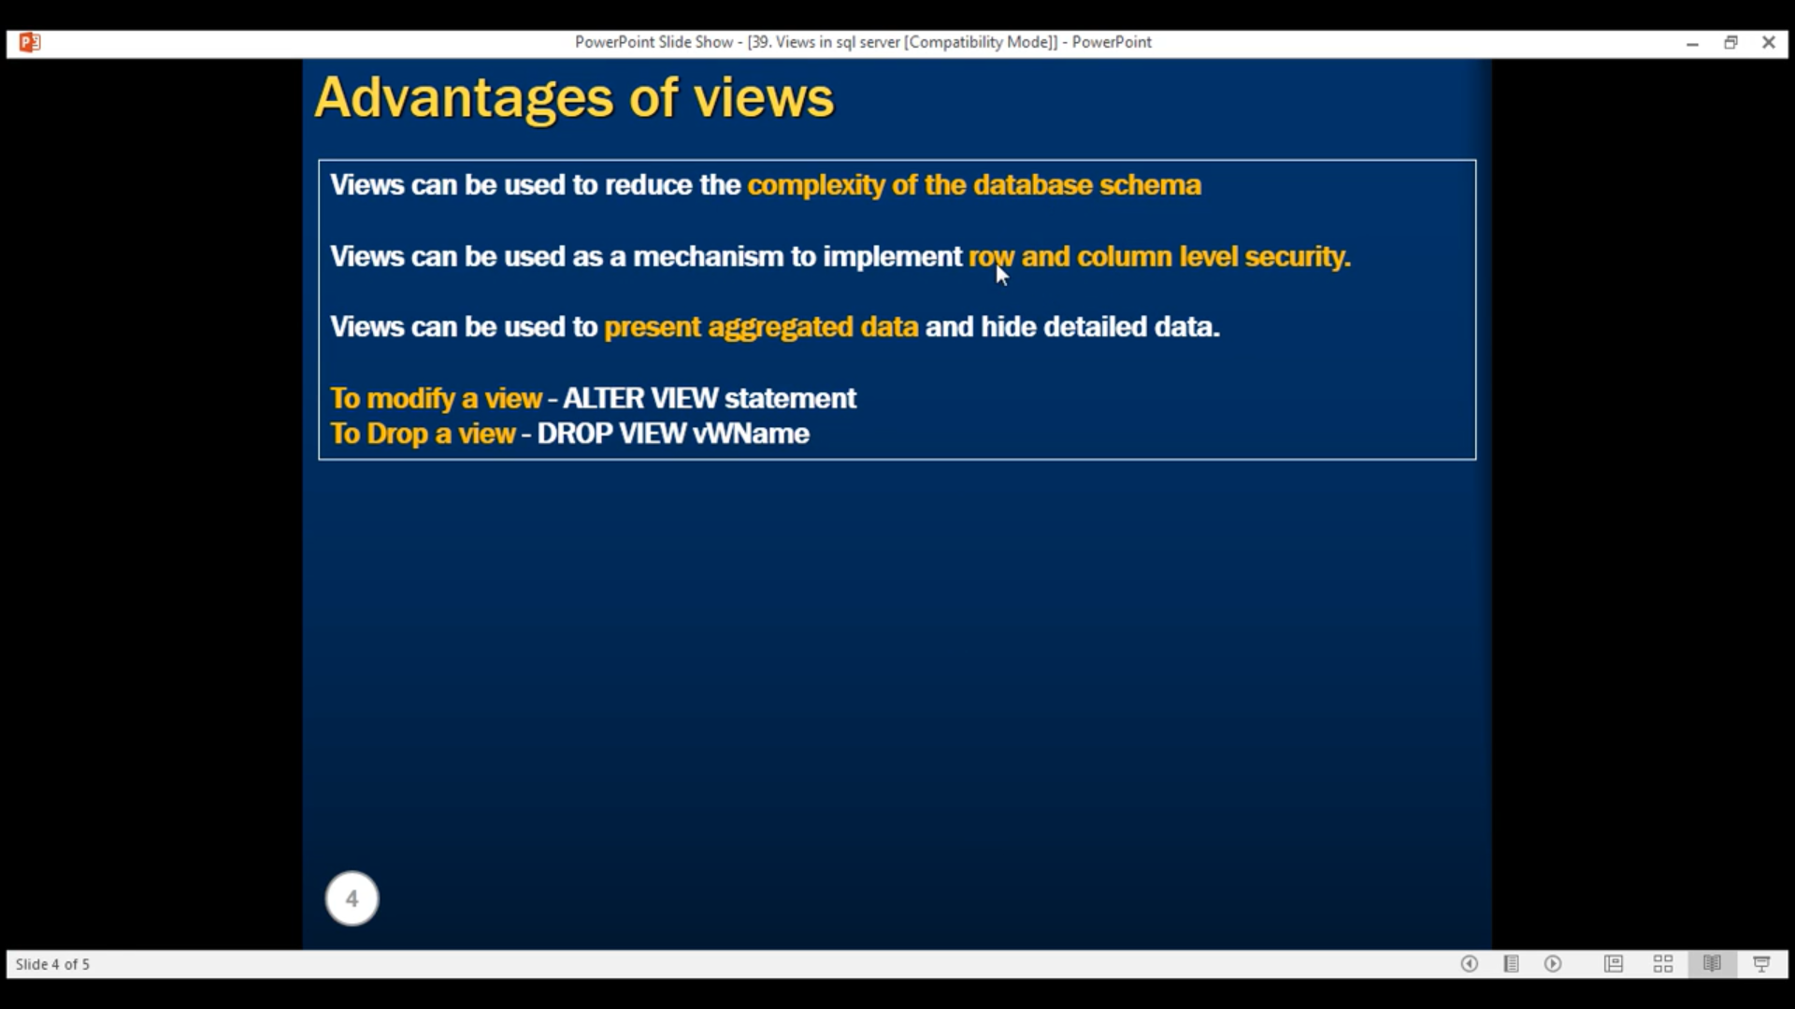

------------------------------------- 40 Updateable Views in sql server

Création d’une vue:

CREATE VIEW vWEmployeesDataExceptSalary

AS

SELECT Id, Name, Gender, DepartementId

From tblEmployee

Modification de la vue : (la modification sur cet exemple va engendrer une modification au niveau de la table réelle)

UPDATE vWEmployeesDataExceptSalary

SET Name = 'Mikey' WHERE Id = 2

Suppression

DELETE FROM vWEmployeesDataExceptSalary WHERE Id = 2

Insertion

INSERT INTO vWEmployeesDataExceptSalary VALUES (2,'Mikey', 'Male', 2)

----------------------------------------------- 42 Indexed views in sql

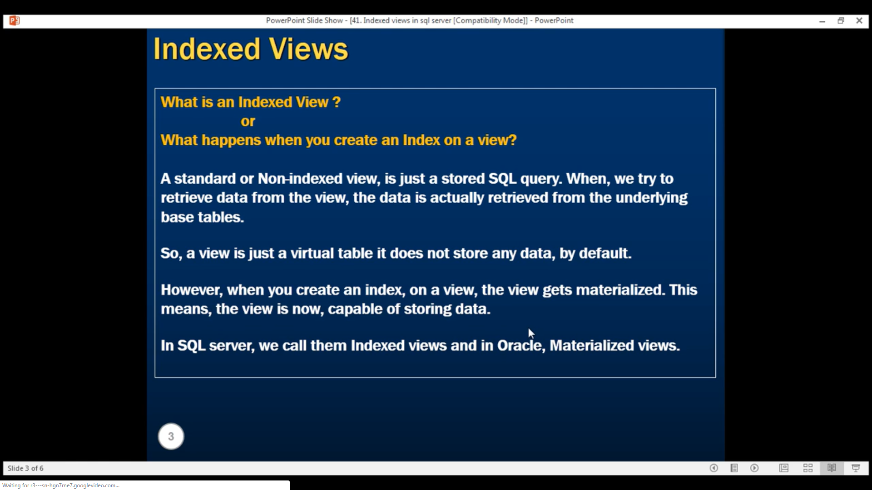

Example: Création de la vue

CREATE VIEW vWTotalSalesByProduct

WITH SchemaBinding

AS

SELECT Name,

SUM(ISNULL((QuantitySold * UnitPrice), 0)) as TotalSaled,

COUNT_BIG(*) as TotalTransactions

FROM dbo.tblProductSales

JOIN dbo.tblProduct

ON tblProduct.ProductId = tblProductSales.ProductId

GROUP BY Name

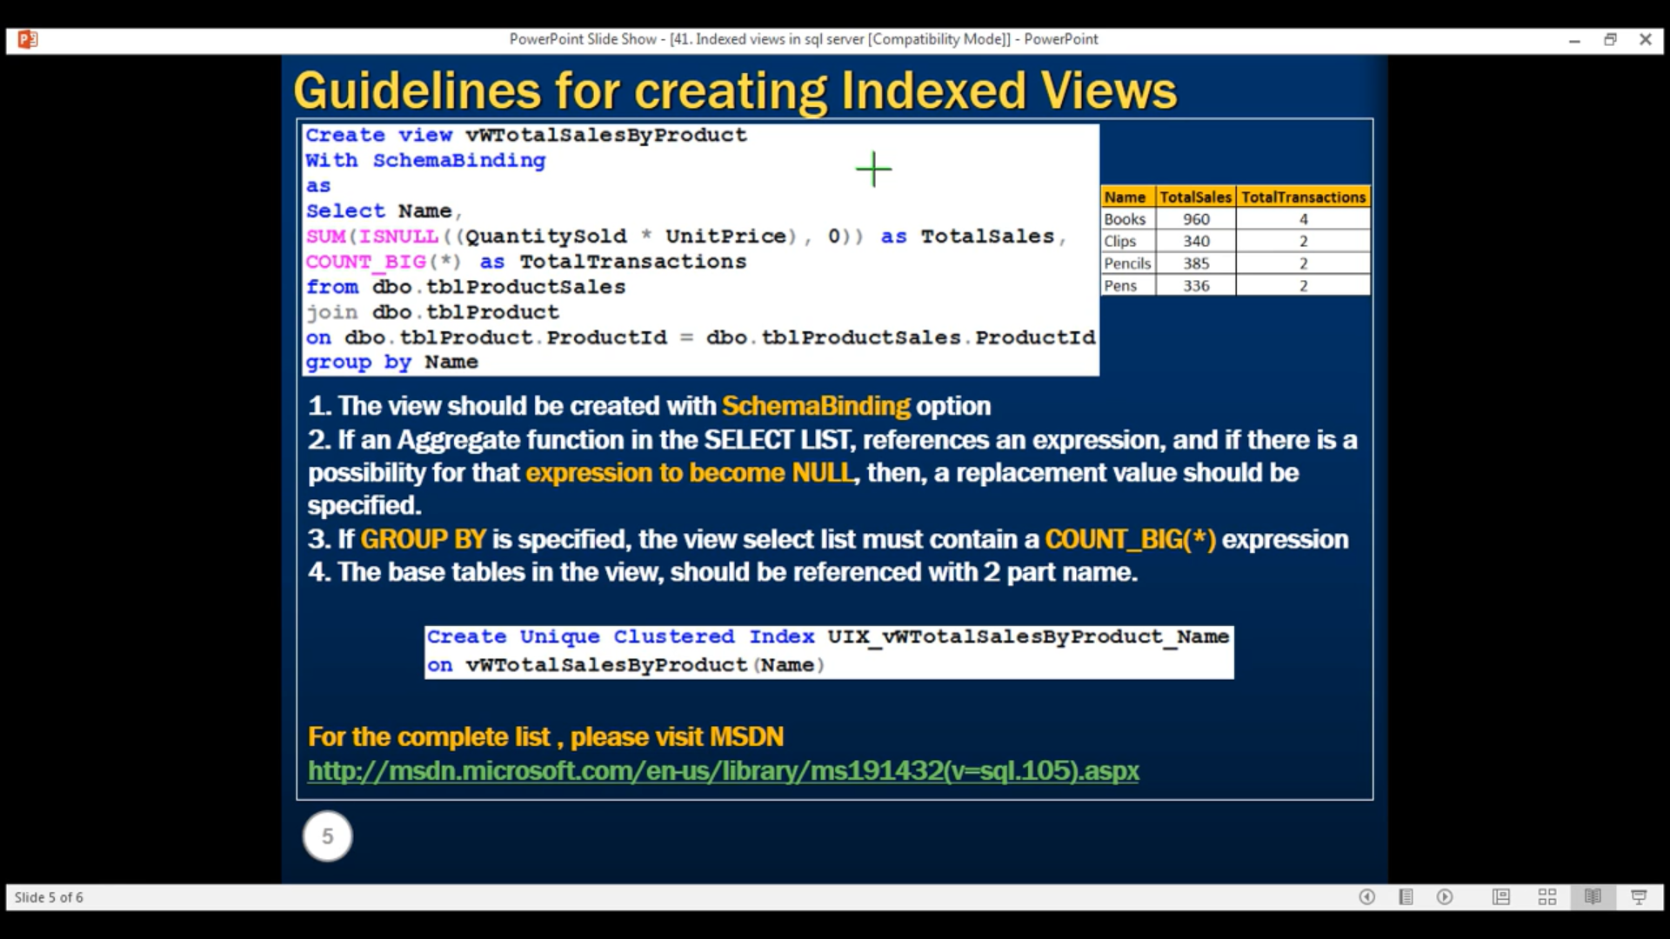

Ajouter l’index à la vue

create table tblEmployee

(

Id int Primary Key,

Name nvarchar(30),

Salary int,

Gender nvarchar(10),

DepartementId int

)

INSERT INTO tblEmployee values (1,'John', 5000, 'Male', 3)

INSERT INTO tblEmployee values (2,'Mike', 3400, 'Male', 2)

INSERT INTO tblEmployee values (3,'Pam', 6000, 'Frmale', 1)

INSERT INTO tblEmployee values (4,'Todd', 5000, 'Male', 4)

INSERT INTO tblEmployee values (5,'Sara', 3200, 'Female', 1)

CREATE UNIQUE CLUSTERED INDEX UIX_vWTotalSalesByProduct_NAME

ON vWTotalSalesByProduct(Name)

Création du Trigger d’insertion (INSERTED is a custom table)

CREATE TRIGGER tr_tblEmployee_ForInsert

ON tblEmployee

FOR INSERT

AS

BEGIN

DECLARE @Id int

SELECT @Id = Id FROM INSERTED

INSERT INTO tblEmployeeAudit

VALUES ('New employee with Id = '+ Cast(@Id as nvarchar(5))+

' is added at ' +

Cast(Getdate() as nvarchar(20))

)

END

Si on insère une ligne, le trigger va être appellé

INSERT INTO tblEmployee values (13,'Soukaina', 3200, 'Female', 1)

Création du Trigger de suppression :

CREATE TRIGGER tr_tblEmployee_ForDelete

ON tblEmployee

FOR DELETE

AS

BEGIN

DECLARE @Id int

SELECT @Id = Id FROM DELETED

INSERT INTO tblEmployeeAudit

VALUES ('An existing employee with Id = '+ Cast(@Id as nvarchar(5))+

' is deleted at ' +

Cast(Getdate() as nvarchar(20))

)

END

----------------------------------------------- 43 Indexed views in sql

ALTER TRIGGER tr_tblEmployee_ForUpdate

ON tblEmployee

FOR UPDATE

AS

BEGIN

-- Declare variables to hold old and updated data

DECLARE @Id int

DECLARE @OldName nvarchar(20), @NewName nvarchar(20)

DECLARE @OldSalary int, @NewSalary int

DECLARE @OldGender nvarchar(20), @NewGender nvarchar(20)

DECLARE @OldDeptId int, @NewDeptId int

-- Variable to build the audit string

DECLARE @AuditString nvarchar(1000)

-- Load the updated records into temporary table

SELECT *

INTO #TEMPTABLE

FROM INSERTED

-- Loop thru the records in temp table

WHILE(Exists(SELECT Id FROM #TempTable))

Begin

--Initialize the audit string to empty string

Set @AuditString = ''

-- Select first row data from temp table

SELECT TOP 1 @Id = Id, @NewName = Name,

@NewGender = Gender, @NewSalary = Salary,

@NewDeptId = DepartementId

FROM #TEMPTABLE

-- Select the corresponding row from deleted table

SELECT @OldName = Name, @OldGender = Gender,

@OldSalary = Salary, @OldDeptId = DepartementId

FROM DELETED WHERE Id = @Id

-- Build the audit string dynamically

SET @AuditString = 'Employee with Id = ' + Cast(@Id as nvarchar(4)) + ' changed'

if(@OldName <> @NewName)

SET @AuditString = @AuditString + ' NAME from ' + @OldName + ' to ' + @NewName

if(@OldGender <> @NewGender)

SET @AuditString = @AuditString + ' GENDER from ' + @OldGender + ' to ' + @NewGender

if(@OldSalary <> @NewSalary)

SET @AuditString = @AuditString + ' SALARY from ' + Cast(@OldSalary as nvarchar(10))+ ' to ' + Cast(@NewSalary as nvarchar(10))

if(@OldDeptId <> @NewDeptId)

SET @AuditString = @AuditString + ' DepartmentId from ' + Cast(@OldDeptId as nvarchar(10))+ ' to ' + Cast(@NewDeptId as nvarchar(10))

INSERT INTO tblEmployeeAudit VALUES(@AuditString)

-- Delete the row from temp table, so we can move to the next row

DELETE FROM #TEMPTABLE WHERE Id = @Id

END

END

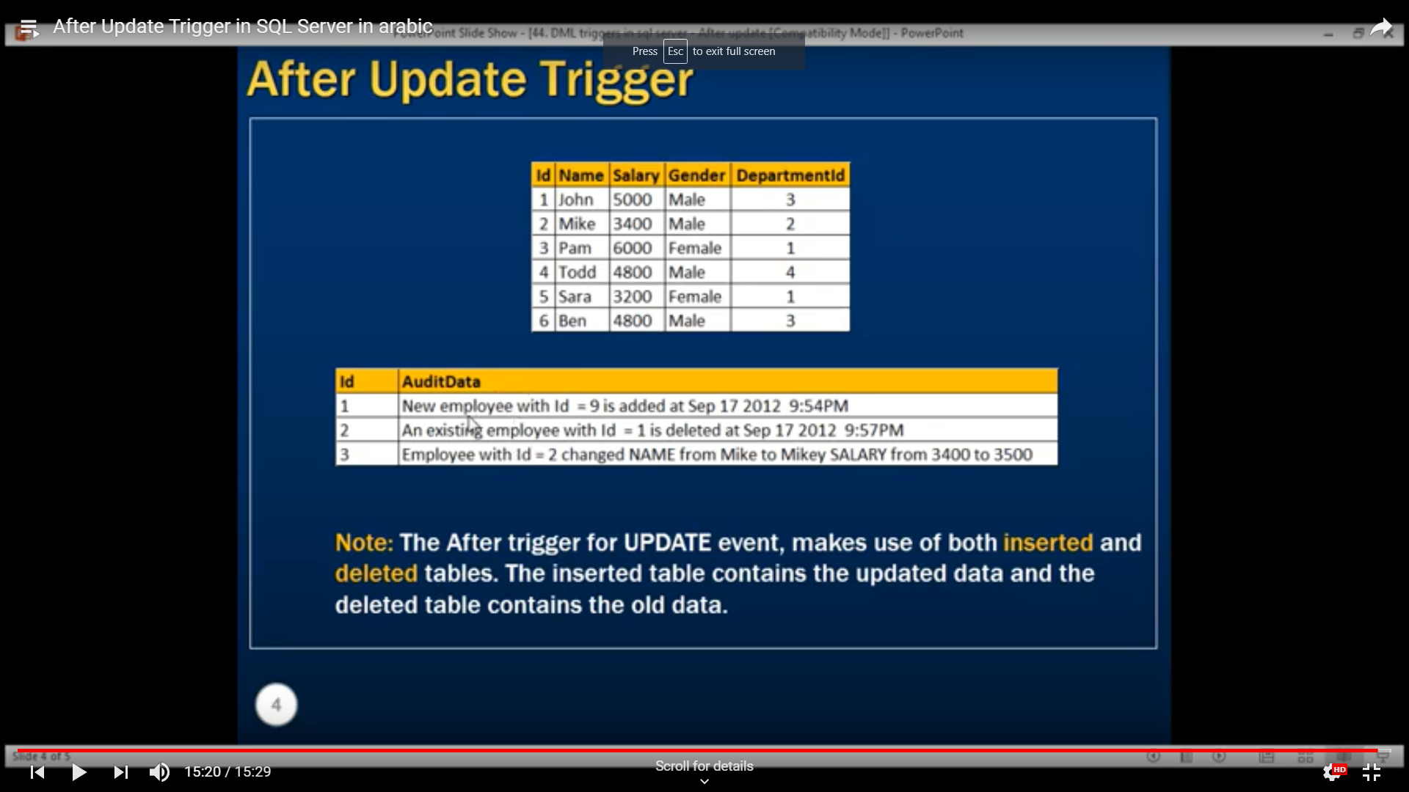

----------------------------------------------- 44 Instead of insert trigger

**In this video we will learn about, INSTEAD OF triggers**, specifically INSTEAD OF INSERT trigger. We know that, AFTER triggers are fired after the triggering event(INSERT, UPDATE or DELETE events), where as, INSTEAD OF triggers are fired instead of the triggering event(INSERT, UPDATE or DELETE events). In general, INSTEAD OF triggers are usually used to correctly update views that are based on multiple tables.   
  
**We will base our demos on Employee and Department** tables. So, first, let's create these 2 tables.  
  
**SQL Script to create tblEmployee table:**  
CREATE TABLE tblEmployee  
(  
  Id int Primary Key,  
  Name nvarchar(30),  
  Gender nvarchar(10),  
  DepartmentId int  
)  
  
**SQL Script to create tblDepartment table**  
CREATE TABLE tblDepartment  
(  
 DeptId int Primary Key,  
 DeptName nvarchar(20)  
)  
  
**Insert data into tblDepartment table**  
Insert into tblDepartment values (1,'IT')  
Insert into tblDepartment values (2,'Payroll')  
Insert into tblDepartment values (3,'HR')  
Insert into tblDepartment values (4,'Admin')  
  
**Insert data into tblEmployee table**  
Insert into tblEmployee values (1,'John', 'Male', 3)  
Insert into tblEmployee values (2,'Mike', 'Male', 2)  
Insert into tblEmployee values (3,'Pam', 'Female', 1)  
Insert into tblEmployee values (4,'Todd', 'Male', 4)  
Insert into tblEmployee values (5,'Sara', 'Female', 1)  
Insert into tblEmployee values (6,'Ben', 'Male', 3)  
  
**Since, we now have the required tables**, let's create a view based on these tables. The view should return Employee Id, Name, Gender and DepartmentName columns. So, the view is obviously based on multiple tables.  
  
**Script to create the view:**  
Create view vWEmployeeDetails  
as  
Select Id, Name, Gender, DeptName  
from tblEmployee   
join tblDepartment  
on tblEmployee.DepartmentId = tblDepartment.DeptId  
  
**When you execute**, **Select * from vWEmployeeDetails**, the data from the view, should be as shown below  
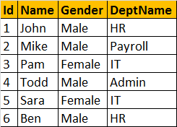  
  
**Now, let's try to insert a row into the view, vWEmployeeDetails**, by executing the following query. At this point, an error will be raised stating 'View or function vWEmployeeDetails is not updatable because the modification affects multiple base tables.'  
Insert into vWEmployeeDetails values(7, 'Valarie', 'Female', 'IT')  
  
**So, inserting a row into a view that is based on multipe tables**, raises an error by default. Now, let's understand, how INSTEAD OF TRIGGERS can help us in this situation. Since, we are getting an error, when we are trying to insert a row into the view, let's create an INSTEAD OF INSERT trigger on the view **vWEmployeeDetails.**  
  
**Script to create INSTEAD OF INSERT trigger:**  
Create trigger tr_vWEmployeeDetails_InsteadOfInsert  
on vWEmployeeDetails  
Instead Of Insert  
as  
Begin  
 Declare @DeptId int  
   
 --Check if there is a valid DepartmentId  
 --for the given DepartmentName  
 Select @DeptId = DeptId   
 from tblDepartment   
 join inserted  
 on inserted.DeptName = tblDepartment.DeptName  
   
 --If DepartmentId is null throw an error  
 --and stop processing  
 if(@DeptId is null)  
 Begin  
 Raiserror('Invalid Department Name. Statement terminated', 16, 1)  
 return  
 End  
   
 --Finally insert into tblEmployee table  
 Insert into tblEmployee(Id, Name, Gender, DepartmentId)  
 Select Id, Name, Gender, @DeptId  
 from inserted  
End  
  
**Now, let's execute the insert query:**  
Insert into vWEmployeeDetails values(7, 'Valarie', 'Female', 'IT')  
  
**The instead of trigger correctly inserts**, the record into tblEmployee table. Since, we are inserting a row, the **inserted** table, contains the newly added row, where as the **deleted** table will be empty.  
  
**In the trigger, we used Raiserror() function**, to raise a custom error, when the DepartmentName provided in the insert query, doesnot exist. We are passing 3 parameters to the Raiserror() method. The first parameter is the error message, the second parameter is the severity level. Severity level 16, indicates general errors that can be corrected by the user. The final parameter is the state. We will talk about Raiserror() and exception handling in sql server, in a later video session.

--------------------------------------55 Error handling in sql server 2000

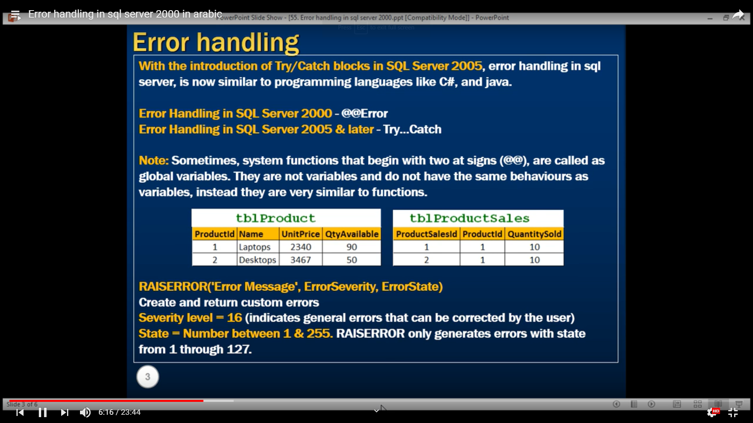

-------------56 -Error handling in sql server 2005 and later versions

Create Procedure spSellProduct

@ProductId int,

@QuantityToSell int

as

Begin

-- Check the stock available, for the product we want to sell

Declare @StockAvailable int

Select @StockAvailable = QtyAvailable

from tblProduct where ProductId = @ProductId

-- Throw an error to the calling application, if enough stock is not available

if(@StockAvailable < @QuantityToSell)

Begin

Raiserror('Not enough stock available',16,1)

End

-- If enough stock available

Else

Begin

Begin Try

Begin Transaction

-- First reduce the quantity available

Update tblProduct set QtyAvailable = (QtyAvailable - @QuantityToSell)

where ProductId = @ProductId

Declare @MaxProductSalesId int

-- Calculate MAX ProductSalesId

Select @MaxProductSalesId = Case When

MAX(ProductSalesId) IS NULL

Then 0 else MAX(ProductSalesId) end

from tblProductSales

--Increment @MaxProductSalesId by 1, so we don't get a primary key violation

Set @MaxProductSalesId = @MaxProductSalesId + 1

Insert into tblProductSales values(@MaxProductSalesId, @ProductId, @QuantityToSell)

Commit Transaction

End Try

Begin Catch

Rollback Transaction

Select

ERROR_NUMBER() as ErrorNumber,

ERROR_MESSAGE() as ErrorMessage,

ERROR_PROCEDURE() as ErrorProcedure,

ERROR_STATE() as ErrorState,

ERROR_SEVERITY() as ErrorSeverity,

ERROR_LINE() as ErrorLine

End Catch

End

End

Si on ne fait pas l’incrémentation du champ ProductSaleId, on reçoit une erreur, car c’est une clé primaire qui ne doit pas être dupliquée

Set @MaxProductSalesId = @MaxProductSalesId + 1

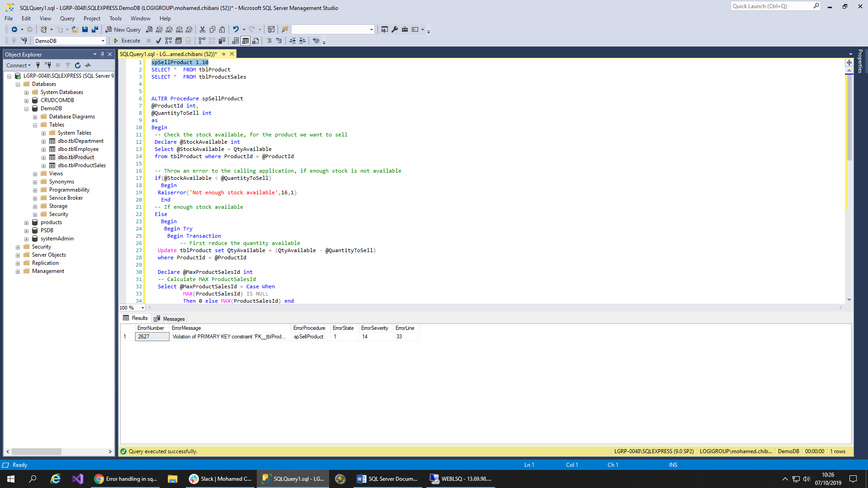

Les erreurs ne vont pas être affichées dans l’applicatif

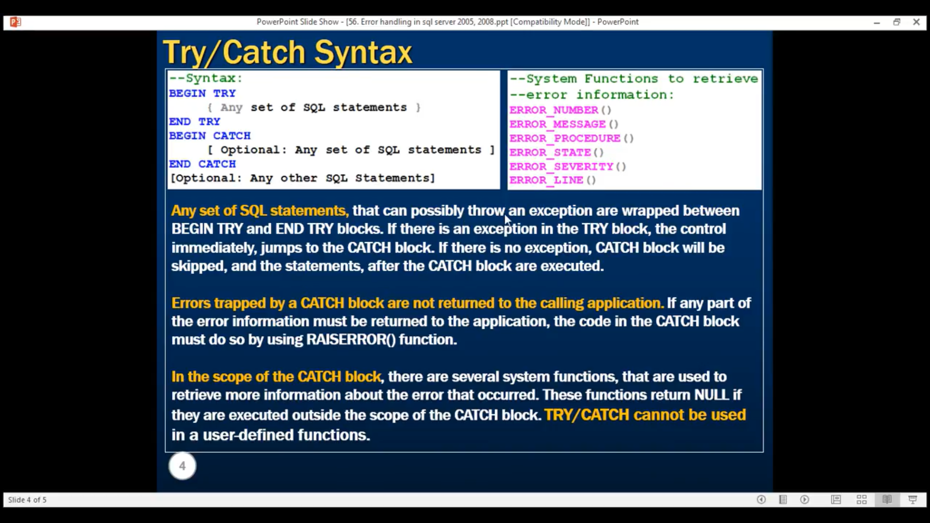

--------------------------------------------- 57 Transactions in SQL Server

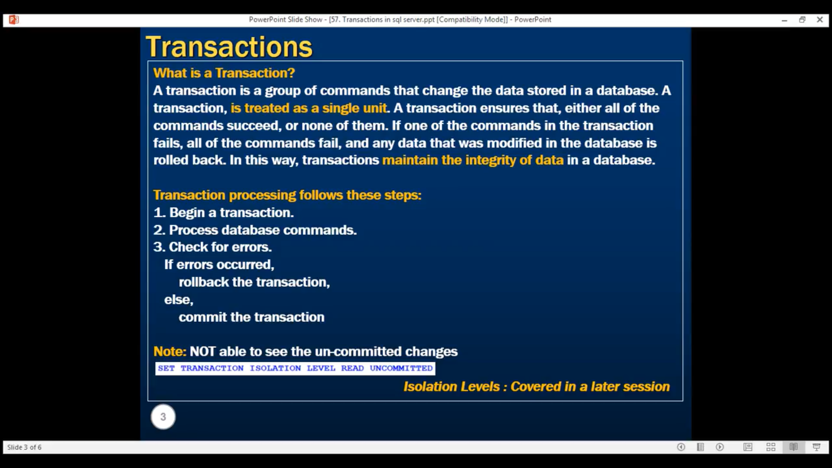

<http://csharp-video-tutorials.blogspot.com/2012/10/transactions-in-sql-server-part-57.html>

Exemple 1 :

Create Procedure spUpdateAddress

as

Begin

Begin Try

Begin Transaction

Update tblMailingAddress set City = 'LONDON'

where AddressId = 1 and EmployeeNumber = 101

Update tblPhysicalAddress set City = 'LONDON'

where AddressId = 1 and EmployeeNumber = 101

Commit Transaction

Print 'Transaction Committed'

End Try

Begin Catch

Rollback Transaction

Print 'Transaction Rollback'

End Catch

End

**Exemple d’erreur:**

Si on modifie la ville par un nom qui dépasse 10 caractères, l’erreur va être catcher et puis le Rollback va être fait

ALTER Procedure spUpdateAddress

as

Begin

Begin Try

Begin Transaction

Update tblMailingAddress set City = 'LONDON1'

where AddressId = 1 and EmployeeNumber = 101

Update tblPhysicalAddress set City = 'LONDON LONDON'

where AddressId = 1 and EmployeeNumber = 101

Commit Transaction

Print 'Transaction Committed'

End Try

Begin Catch

Rollback Transaction

Print 'Transaction Rollback'

End Catch

End

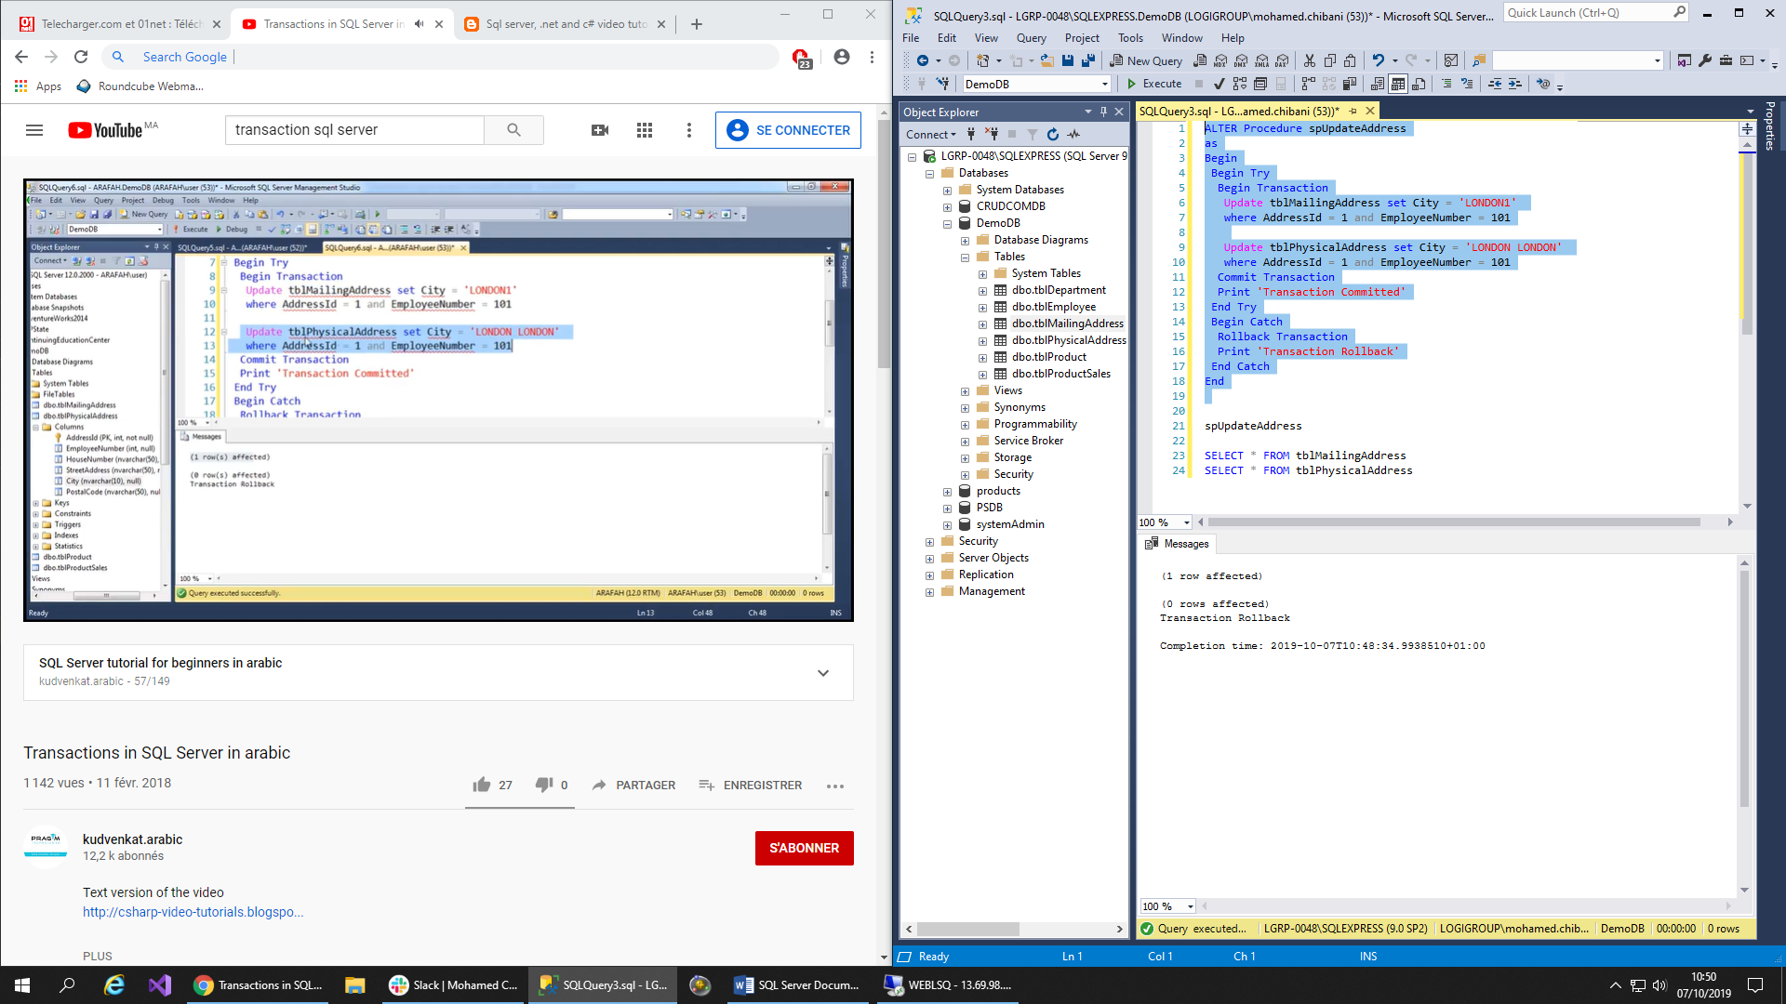

------------------------------------ 58 SQL transactions and ACID Tests

